**FOR IMMEDIATE RELEASE *– DATE* MONTH XX, 20XX**

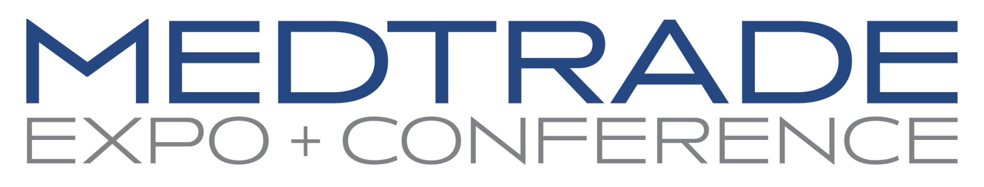

***HEADLINE***

PHOENIX –

**[YOUR NAME] [YOUR TITLE] OF [YOUR COMPANY] SET TO SPEAK AT MEDTRADE**

*Medtrade Conference will take place [DATE OF SHOW]*

[YOUR CITY] -Since 1979, Medtrade has brought the Home Medical Equipment industry together to connect, share ideas, and experience the newest DMEPOS technology and personal health products.

[YOUR COMPANY] is proud to announce that [YOUR TITLE] [YOUR NAME] has been selected to speak at the upcoming conference and provide industry knowledge and expertise to the event’s conference attendees.

The educational session is titled, [SESSION TITLE]. During this session, attendees will learn [USE YOUR SESSION’S DESCRIPTION FROM THE CONFERENCE AGENDA ON THE MEDTRADE WEBSITE. INCLUDE BULLETS OF THE KEY TAKEAWAYS, IF AVAILABLE]

[YOUR COMPANY] is proud to support the Home Medical Industry by attending this annual conference with our team. The new products discovered, education received, and connections we make will only allow us to better serve our customers.

***[OPTIONAL: INCLUDE A QUOTE ON WHY YOU ARE LOOKING FORWARD TO SPEAKING AT MEDTRADE]***

**About Emerald**

Emerald’s talented and experienced team grows our customers’ businesses 365 days a year through connections, content, and commerce. We expand connections that drive new business opportunities, product discovery, and relationships with over 140 annual events, matchmaking, and lead-gen services. We create content to ensure that our customers are on the cutting edge of their industries and are continually developing their skills. And we power commerce through efficient year-round buying and selling. We do all this by seamlessly integrating in-person and digital platforms and channels.  Emerald is immersed in the industries we serve and committed to supporting the communities in which we operate.  As true partners, we create experiences that inspire, amaze, and deliver breakthrough results. For more information, please visit: [www.emeraldx.com](http://www.emeraldx.com/)

**About Medtrade**

Medtrade is the largest home medical equipment trade event in North America, bringing together manufacturers, providers, and retailers from across the country and around the world. Established in 1979, the show gathers hundreds of HME related brands, thousands of attendees,and are highly regarded industry events. Medtrade is owned by Emerald, the largest operator of business-to-business trade shows in the United States. [www.medtrade.com](http://www.medtrade.com)

**CONTACT:** Greg Thompson

Medtrade Media Relations;   
(970) 227-1002

[greg.thompson91@yahoo.com](mailto:greg.thompson91@yahoo.com)